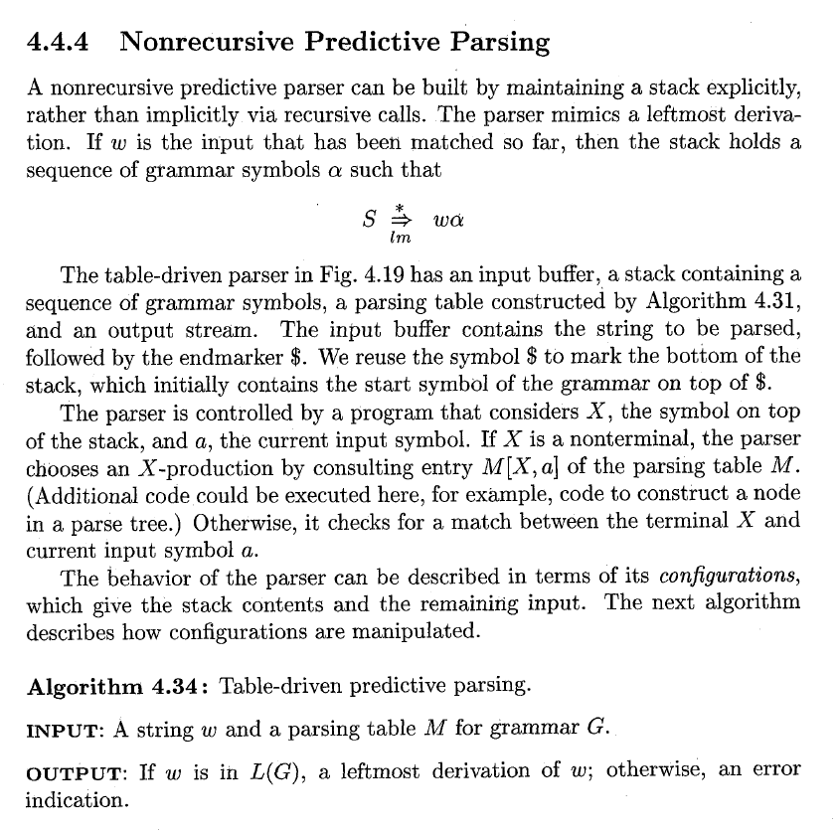

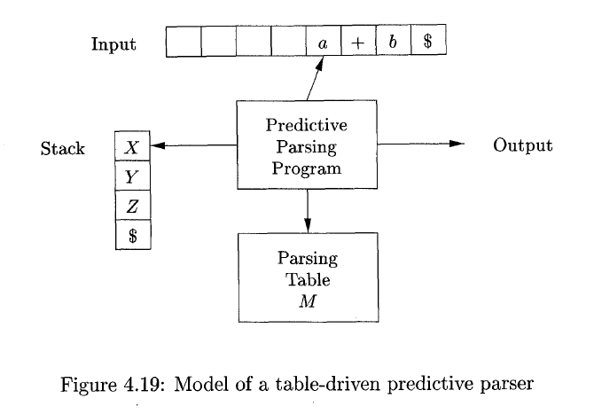
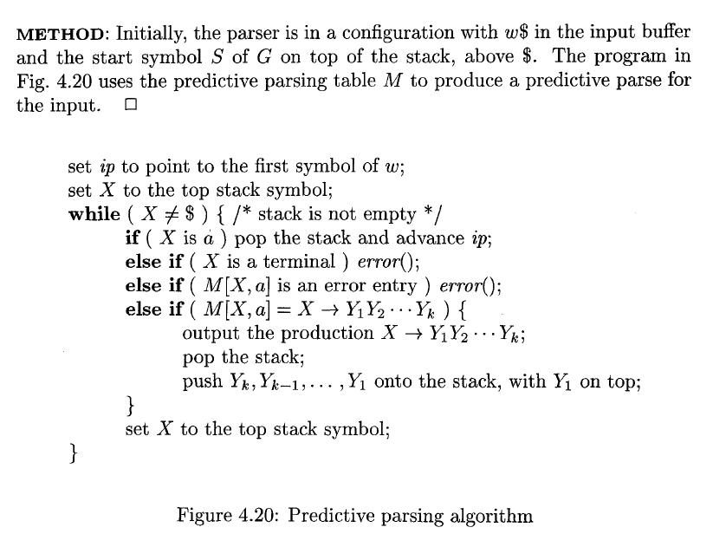

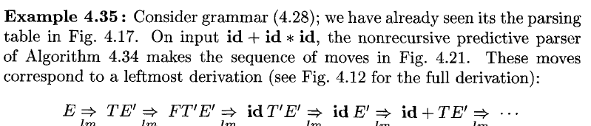
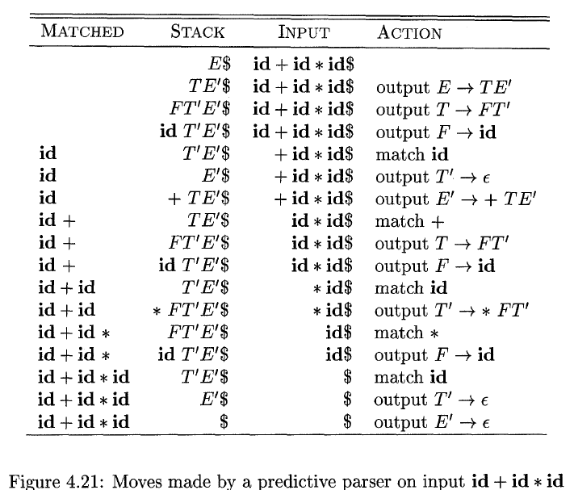

Error Recovery in Predictive Parsing
An error is detected during predictive parsing when the terminal on top of the stack does not match the next input symbol or when nonterminal A is on top of the stack, a is the next input symbol, and M[A, a] is error (i.e., the parsing-table entry is empty).

Panic Mode
Panic-mode error recovery is based on the idea of skipping symbols on the input until a token in a selected set of synchronizing tokens appears. Its effectiveness depends on the choice of synchronizing set. The sets should be chosen so that the parser recovers quickly from errors that are likely to occur in practice. Some heuristics are as follows:
- As a starting point, place all symbols in FOLLOW(A) into the synchronizing set for nonterminal A. If we skip tokens until an element of FOLLOW(A) is seen and pop A from the stack, it is likely that parsing can continue.

- It is not enough to use FOLLOW(A) as the synchronizing set for A. For example, if semicolons terminate statements, as in C, then keywords that begin statements may not appear in the FOLLOW set of the nonterminal representing expressions. A missing semicolon after an assignment may therefore result in the keyword beginning the next statement being skipped. Often, there is a hierarchical structure on constructs in a language; for example, expressions appear within statements, which appear within blocks, and so on. We can add to the synchronizing set of a lower-level construct the symbols that begin higher-level constructs. For example, we might add keywords that begin statements to the synchronizing sets for the nonterminals generating expressions.

- If we add symbols in FIRST(A) to the synchronizing set for nonterminal A, then it may be possible to resume parsing according to A if a symbol in FIRST(A) appears in the input.

- If a nonterminal can generate the empty string, then the production deriving E can be used as a default. Doing so may postpone some error detection, but cannot cause an error to be missed. This approach reduces the number of nonterminals that have to be considered during error recovery.

- If a terminal on top of the stack cannot be matched, a simple idea is to pop the terminal, issue a message saying that the terminal was inserted, and continue parsing. In effect, this approach takes the synchronizing set of a token to consist of all other tokens.

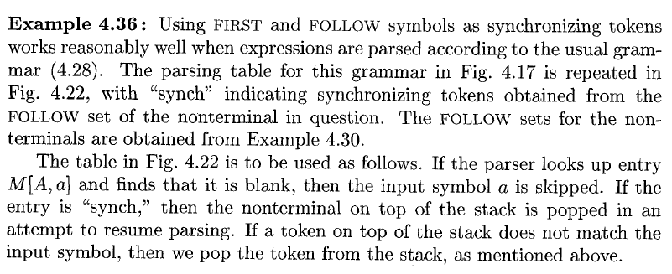

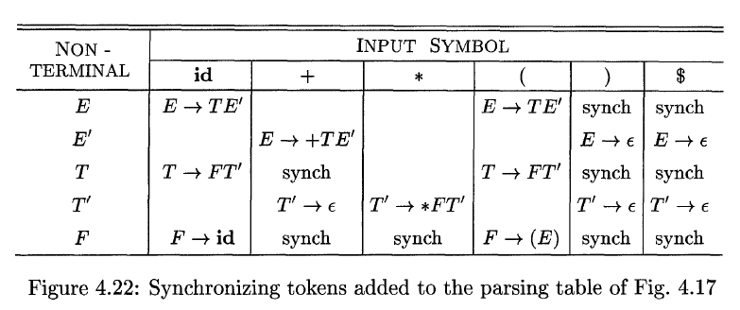

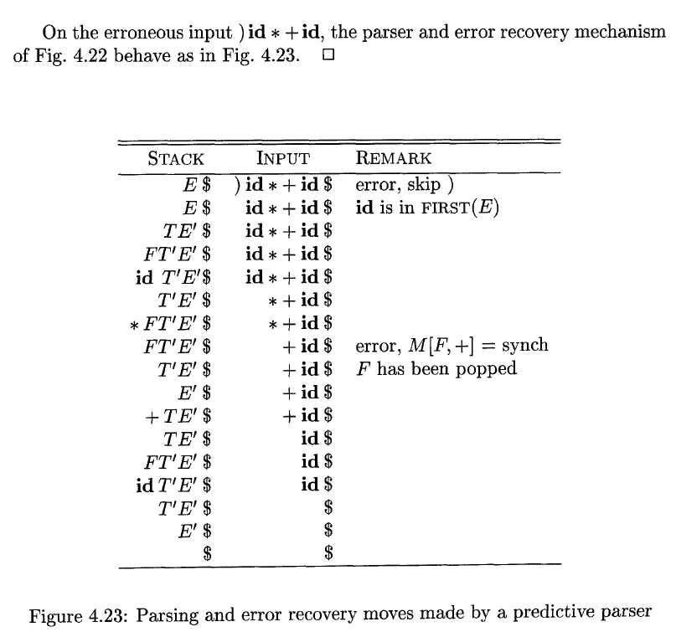

The above discussion of panic-mode recovery does not address the important issue of error messages. The compiler designer must supply informative error messages that not only describe the error, they must draw attention to where the error was discovered.

Phrase-level Recovery
Phrase-level error recovery is implemented by filling in the blank entries in the predictive parsing table with pointers to error routines. These routines may change, insert, or delete symbols on the input and issue appropriate error messages. They may also pop from the stack. Alteration of stack symbols or the pushing of new symbols onto the stack is questionable for several reasons. First, the steps carried out by the parser might then not correspond to the derivation of any word in the language at all. Second, we must ensure that there is no possibility of an infinite loop. Checking that any recovery action eventually results in an input symbol being consumed (or the stack being shortened if the end of the input has been reached) is a good way to protect against such loops.

